**MGen CA3 rules**

Contents

Definitions, principles and limitations 3

Definitions 3

1. Counterpoint 3

2. Strict counterpoint 3

3. Cantus firmus 3

Principles 3

4. Modes 3

5. Main principles of combining the voices 3

6. Harmonic and melodic notes 4

7. Harmonic intervals 4

8. Chords 5

9. Melodic notes 5

Limitations 5

10. Number of voices 5

11. Vocal ranges 5

12. Counterpoint species 5

13. Mixed species 6

14. Voice order 6

15. General counterpoint principles 6

Rhythm rules 7

16. Time signature 7

17. Rhythmic limitations of each counterpoint species 7

18. First measure 7

19. Last measure 7

20. Mixed species 7

Fifth species counterpoint 8

21. Allowed rhythms 8

22. First measure 8

23. Rhythms distribution 9

Melodic rules 10

24. Stepwise movement 10

25. Leaps 10

26. Leaps between measures 10

27. Melodic intervals between two sequential notes 10

28. Melodic intervals between more than two consecutive notes 11

29. Obligatory note preparation 12

30. Obligatory movement between notes 12

31. Notes repeat 12

32. Melody organization 12

Melodic minor 13

33. Two forms of melodic minor 13

34. Use of melodic notes VI# or VII 13

35. Use of harmonic tones VI# or VII 13

36. Close positioning of two forms of VI or VII degree in melodic minor  13

Harmonic rules 15

37. Contrary motion of voices 15

38. Oblique motion 15

39. Similar motion 15

40. Sequential 3rds, 4ths and 6ths 15

41. Similar motion to 3rd, 4th or 6th 16

42. Sequential 5ths or 8ves 16

43. 5ths or 8ves, separated by one or multiple notes 16

44. Similar motion to 5th or 8ve between extreme voices 18

45. Similar motion to 5th or 8ve between internal voices 18

46. Sequential 2nds, 7ths, 9ths 19

47. Similar motion to 2nd, 7th and 9th 19

48. 2nd, 7th or 9th at the beginning of the voice 20

49. Distance between voices 20

50. Voice crossing 20

51. Voice crossing arrangement 21

52. Doubling 21

53. Unison 21

54. 4th. Diminished 5th. 22

55. Harmonic tritone 22

56. Second inversion chords 23

57. Obligatory harmonies 23

58. Incomplete chords 24

59. Harmonic rhythm 24

60. Modulation 25

Non-chord tones 25

Suspensions 25

61. Suspensions, which resolve down 25

62. Suspensions, which resolve up 25

63. Suspension preparation 25

64. Suspension resolution 26

65. Suspension and resolution 27

Passing and auxiliary tones 27

66. Passing and auxiliary tones 27

67. Simultaneous sounding of melodic and harmonic notes 28

68. Double neighbor tones 28

# Definitions, principles and limitations

## Definitions

### Counterpoint

Counterpoint is the science of melodic lines and their interactions. Counterpoint studies music in horizontal aspect.

Harmony is science of chords and their combinations – studies music in vertical aspect. Harmony and counterpoint complement each other.

### Strict counterpoint

Strict or scholar counterpoint studies interaction of short vocal melodies without modulations[1].

These melodies have to be written over cantus firmus (c.f.) while following strict rules.

### Cantus firmus

A given melody, which should be combined with a new melody during counterpoint exercise. C*antus firmus* is written in whole notes in one of modes described below.

## Principles

### Modes

Counterpoint is studied in classic major and minor scales, and also in ancient modes.

|  |  |
| --- | --- |
| *Major* |  |
| *Melodic minor* |  |
| *Dorian mode* |  |
| *Phrygian mode* |  |
| *Lydian mode* |  |
| *Mixolydian mode* |  |
| *Aeolian mode* |  |

Ancient modes, which are interesting due to their specific sound, are easier to use in counterpoint, than melodic minor. Melodic minor rules can be found starting from §33.

### Main principles of combining the voices

Voices are combined with cantus firmus and with other voices so that they form consonances on the first beat of each harmony[2]. Each voice can move more freely between these reference points. This freedom leads to unexpected combinations of notes, which constitute the main interest of counterpoint. These note combinations should be evaluated by ear. Even if the voice starts not on the first beat of the first measure, the first note of the voice follows the same rules as each note on the first beat of the harmony.

In case of suspension, the note which resolves the suspension should form consonance[3].

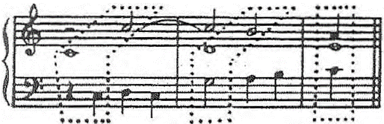

### Harmonic and melodic notes

Notes, which have to form consonances, have both vertical and horizontal meaning. They can be called “chord tones” shortly.

Melodic notes surround chord tones. They have only horizontal meaning.

In strict counterpoint we allow a small number of harmonic and melodic tones due to use of diatonic and triads.

All notes of major mode and ancient modes can have harmonic or melodic meaning. It is not true for melodic minor (see §34 и §35).

### Harmonic intervals

The following intervals (simple or compound) are considered consonances between voices:

|  |  |
| --- | --- |
| *Perfect octave* |  |
| *Perfect 5th* |  |
| *Major and minor 3rd* |  |
| *Major and minor 6th* |  |

Unison is allowed in particular cases (see §53).

Perfect 4th, augmented 4th and diminished 5th are allowed between two voices except bass (see §54).

### Chords

Only the following chords are allowed:

* Major chord in root position and first inversion (6th chord):

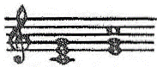

* Minor chord in root position and first inversion (6th chord):

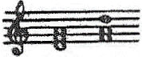

* First inversion of diminished chord (6th chord):

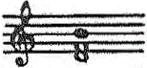

* Diminished chord in root position is allowed only when harmonic tritone is allowed (see §55).

### Melodic notes

Suspensions, passing tones and auxiliary tones are used.

All of these notes should resolve correctly:

1. Suspension resolution rules are described starting from §61.
2. Passing tone should be followed by chord tone or another passing tone in same direction.
3. Auxiliary tone should be surrounded by chord tones on both sides.

## Limitations

### Number of voices

School counterpoint is written for vocal ensemble of 2 to 8 voices.

We will study counterpoint in 2, 3, 4, 5, 6, 7, 8 voices successively.

### Vocal ranges

Voices should be limited in the following ranges:

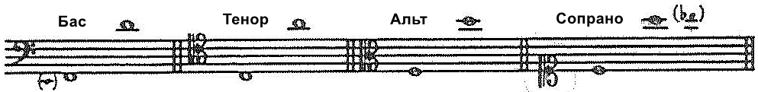

Do not overuse notes that are close to the limits of these ranges (lower and higher).

Also, range of each voice should not exceed 11th (4th with an octave). As an exception, 12th (5th with an octave) is allowed, when it is justified by long stepwise movement.

### Counterpoint species

Counterpoint is studied in 5 species. Each species is characterized by obligatory rhythm (see §17).

Starting from 5 voices and above, we limit our study to only first species (whole notes) and 5th species (free rhythm counterpoint).

### Mixed species

In 3 and 4 voices we can mix different species of counterpoint in the same exercise. In this case each voice belongs to one particular species. 5th species should not be combined with species 2, 3, or 4.

There should always be one whole note cantus firmus in each exercise. Other whole note voices are considered to be in species 1.

### Voice order

In each species or species mix, *cantus firmus* is located successively in each voice, which gives more combinations.

*Cantus firmus* can be transposed when it is being moved to another voice.

### General counterpoint principles

Counterpoint rules create limits, which contribute to development of music imagination of a student. Student should achieve flexibility, independence and variety of melodic lines.

The strictness of the rules decreases with increase in voice count. If additional voices are introduced during the course of the exercise, more rules can be ignored as soon as enough voices start to sound simultaneously.

Imitations should be avoided in simple counterpoint, because they are studied in separate exercise.

# Rhythm rules

### Time signature

We usually study binary counterpoint (2 or 4 notes against one note). It is also useful to write counterpoint in other time signatures.

In this book rules are usually in 2/2 time, while cantus firmus usually consists of whole notes.

Each measure has downbeat and upbeats:

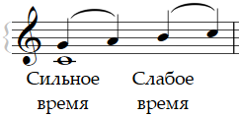

In this example, note G sounds on downbeat (first beat). Notes A, B and C sound on upbeat (second, third and fourth beats).

### Rhythmic limitations of each counterpoint species

**Species 1**. One note against one note. Counterpoint is written using whole notes.

**Species 2**. Two notes against one note. Counterpoint is written using half notes and starts with half note rest. For more counterpoint endings diversity, suspension is allowed in penultimate measure if it resolves to a leading tone.

**Species 3**. Four notes against one note. Counterpoint is written using quarter notes and starts with a quarter note rest.

**Species 4**. Syncopations. Counterpoint is written using slurred half notes and starts with a half note rest. In difficult cases, at least one syncopation can be broken per exercise.

**Species 5**. Counterpoint in free rhythm. This counterpoint can use all rhythms of previous species, and also some additional rhythms (see §§ 21-23).

Starting from three voices and above, only one voice obeys rhythmic rules of species 2, 3, 4. Other voices use whole notes only. In species 5, on the contrary, only cantus firmus uses whole notes.

### First measure

No rests are allowed in cantus firmus.

Counterpoint voice always starts with a rest, except for species 1. No more rests are allowed in counterpoint voices apart from this starting rest.

### Last measure

Counterpoint in any species in any number of voices always ends with a whole note.

### Mixed species

In mixed species each voice has its own rhythm.

**In three voices** *cantus firmus* is combined with half notes, quarter notes, or syncopations.Voices should be introduced as close to each other, as possible, but not simultaneously[4]. Such a mixed species is called *mélange*.

**In four voices** *cantus firmus* is combined with half notes, quarter notes or syncopations. Such a mixed species is called *grand mélange*.

In the second measure one half note or syncopation can be introduced. Other voices should be introduced in first measure.

## Fifth species counterpoint

### Allowed rhythms

The following rhythms are allowed:

* The rhythms of previous counterpoint species, except for whole notes:



* New rhythms:



* Quavers:



Quavers should be written in pairs; they should be surrounded by stepwise movement. Quavers should never appear on downbeat. Number of quavers should be limited.

There should not be more notes than four in one measure.

**Exceptions**:

These rhythms are allowed without syncopations only in penultimate measure, irrespective of number of voices:  or 

There rhythms are allowed starting from three voices and above:  or 

These rhythms without syncopations and also a whole note within the exercise are allowed starting from five voices and above[5]:  or 

### First measure

The following rhythms are allowed in the first measure:

* Rhythms used in first measure of previous counterpoint species:



* New rhythm: 

**Exception**:

This rhythm is allowed at voice start:  This allows three voices to start in a single measure.

### Rhythms distribution

1. In a single voice neighboring measures should not have the same rhythm. It is not allowed to use more than 3 half notes or more than 7 quarter notes in two consecutive measures[6]. Also, it is not allowed to write two syncopations in a row.
2. Two voices should not have same rhythm in the same measure. Starting from three voices and above, each beat (quarter) should be marked with note start in any voice. Suspension gets rid of this obligation:

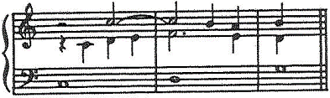

**Exception**:

Starting from 5 voices and above half notes and quarter notes can be imposed over each other.

# Melodic rules

### Stepwise movement

The stepwise movement should be used as much as possible. The stepwise movement in conjunction with the contrary movement comprises the essence of the counterpoint.

### Leaps

Leaps should be avoided for as long as possible, especially between shorter notes. Leaps from a quaver or to a quaver are prohibited.

Arpeggios are prohibited in a melodic line.



Exception: arpeggio is allowed when melody direction changes:



### Leaps between measures

Leaps between measures should be particularly avoided, especially from or two shorter notes (shorter than half note).

**Exception**:

Leaps are allowed between measures, if melody moves in an opposite direction before the leap[7]:



### Melodic intervals between two sequential notes

1. Allowed:
   1. Minor, major and perfect intervals less or equal to minor 6th (minor 3rd, major 3rd, perfect 4th, perfect 5th, minor 6th).
   2. Perfect octave.



1. Prohibited:
   1. Chromatic intervals
      1. intervals formed by non-diatonic notes;
      2. intervals between altered and non-altered forms of the same degree.
   2. Diminished and augmented intervals.
   3. Intervals longer than minor 6th (except for perfect octave).



Leaps of an octave should not be abused.

**Exception**:

Starting from 6 voices and above, major 6th is allowed in difficult cases.

### Melodic intervals between more than two consecutive notes

1. Augmented 4th within 3 or 4 neighboring notes should be prepared or left by stepwise movement in the same direction:





1. Augmented 5th within four neighboring notes should be left by stepwise movement:

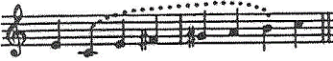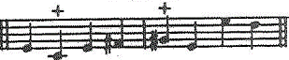

1. 7th and 9th within three notes should contain stepwise movement in the same direction:



Under these conditions 7th suit perfectly irrespective of notes length. 9th suits perfectly in species 1 or 4, and also is possible in half notes, but it should be avoided between quarter notes.

1. Octave should be prepared and left by opposite movement, where possible:



Two consecutive octave or 6th leaps are allowed in difficult cases:



### Obligatory note preparation

Suspension is the only note that has to be prepared obligatory. Preparing note should not be shorter than a half note (see § 63).

### Obligatory movement between notes

All melodic notes (suspensions, passing and auxiliary tones) should be surrounded by stepwise movement (except double neighboring tones). Harmonic do not have such a limitation and can be surrounded by leaps. Leading tone in counterpoint has to resolve to tonic only in cadence. Leading tone in counterpoint does not need to resolve within the exercise.

### Notes repeat

Note should not be followed by note of the same pitch in any voice in any counterpoint species.

Starting from 5 voices and above, whole notes can be repeated in species 1[8], but such a repeat should be used as seldom as possible.

### Melody organization

Melody should develop permanently without symmetry or repeats.

The following should be avoided:

1. Regular leaps (for example, after each 4 or 8 notes):



1. Repeat of melodic fragments:



1. Return three times to the same note. It can be allowed in difficult cases:



## Melodic minor

### Two forms of melodic minor

Melodic minor can be presented in one of two forms, depending on melody direction:

|  |  |
| --- | --- |
| Ascending form: |  |
| Descending form: |  |

### Use of melodic notes VI# or VII

Notes F# or G natural in previous example are melodic. They are used as passing or auxiliary notes in the following cases:

|  |  |
| --- | --- |
| Passing tone: |  |
| Auxiliary tone: |  |

### Use of harmonic tones VI# or VII

1. Note F# can be harmonic only inside an ascending stepwise movement:

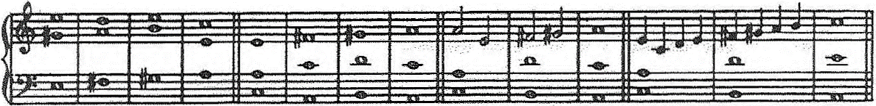

1. Note G natural can be harmonic only inside a descending stepwise movement:

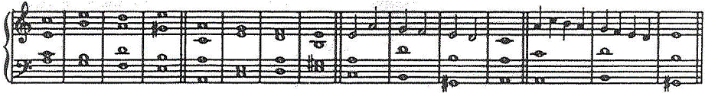

Avoid doubling of notes VI# or VII.

### Close positioning of two forms of VI or VII degree in melodic minor

1. Altered and unaltered forms of the same note (VI or VII degrees in melodic minor) should not be used in the same voice close to each other. At least 3 other notes should be placed between them:



In difficult cases it is acceptable that these notes can become closer:

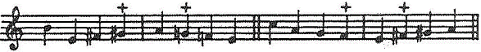

1. False chromatic relation is a chromatic contradiction between the altered and the unaltered forms of the same note sounding simultaneously (or in close proximity), in two different voices. It is allowed in close proximity only when there is another harmony between related notes or when at least one of the related notes is not a chord tone:

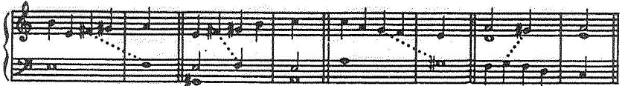

Starting from 3 voices and above, false chromatic relation of chord tones is allowed between non-extreme voices, especially when related notes are separated in time by other notes.

Simultaneous false chromatic relation is acceptable only when related notes do not start on the same beat. In such case at least one of the related notes is always not a chord tone:

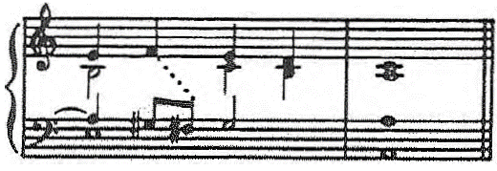

# Harmonic rules

To get best sound from counterpoint ensemble, voices movement should be strictly controlled[9]. In this section you will find the rules, which work for any pair of voices in counterpoint. Also, counterpoint chord rules also can be found in this section.

### Contrary motion of voices

Contrary motion of voices should be used as much as possible, especially between extreme voices.

Contrary stepwise motion sounds great and comprises the essence of the counterpoint.

### Oblique motion

Oblique motion also sounds great.

Only oblique motion to unison is not allowed in some cases (see § 53).

### Similar motion

Similar motion is generally undesired and should be used as seldom as possible.

Its usage is regulated by rules, which are described below.

### Sequential 3rds, 4ths and 6ths

Do not use more than 3 sequential 3rds, 4ths or 6ths of the same duration (parallel motion)[10].

Do not use three 6th chords sequentially in whole notes if all voices have similar motion[11]:

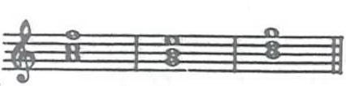

In counterpoint species 4, sequential 3rds, 4ths or 6ths, which occur due to syncopations, are allowed without limitations.

### Similar motion to 3rd, 4th or 6th

Allowed.

### Sequential 5ths or 8ves

Two sequential perfect 5ths or 8ths are prohibited, even in contrary motion:

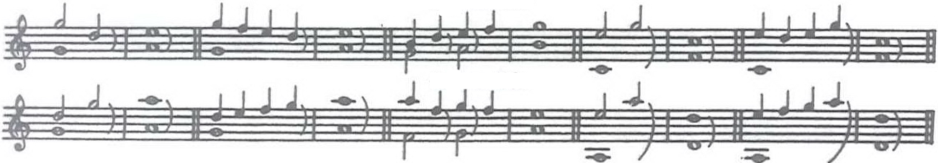

Unison is subjected to the same rule as octave. It is prohibited to use two sequential unisons or octave after unison (or unison after octave):

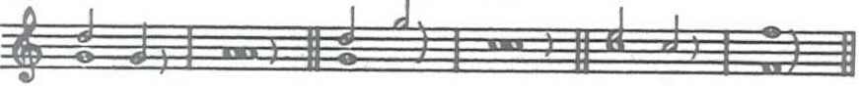

**Exceptions**:

Starting from 6 voices and above, sequential perfect 5ths or 8ves are allowed in contrary motion between internal voices.

Starting from 7 voices and above, sequential perfect 5ths or 8ves are allowed in contrary motion between any voices.

Starting from 3 voices and above, diminished 5th is allowed immediately after perfect 5th. Perfect 5th is always prohibited immediately after diminished 5th.

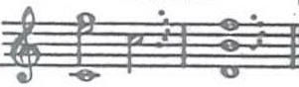 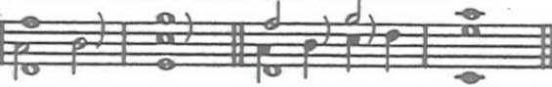

### 5ths or 8ves, separated by one or multiple notes

Such 5ths or 8ves are allowed when they are separated by at least a whole or its equivalent (e.g. two half notes or four quarter notes):

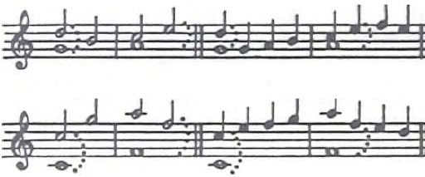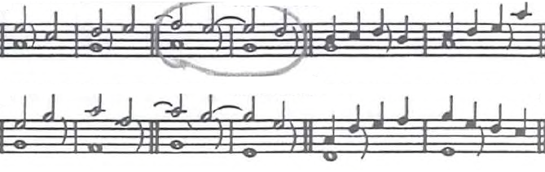

**Exceptions**:

5ths or 8ves, separated by less than a whole note, are allowed in the following cases if the second interval (5th or 8ve) is not on first beat of the measure:

1. In contrary motion:

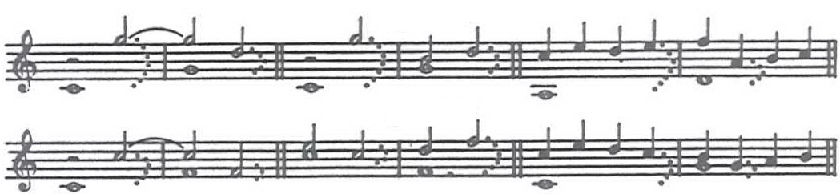

1. Even in similar motion, when one of the intervals is formed by a melodic note[12]:

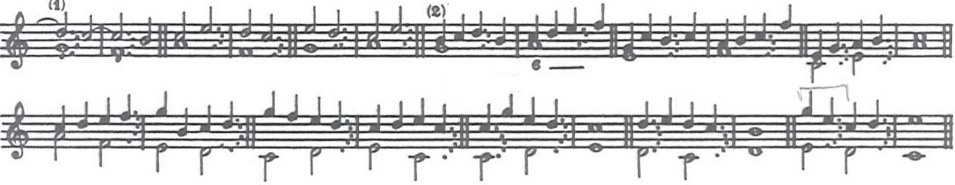

Starting from 5 voices and above, 5ths or 8ves, separated by one half note or two quarter notes, are allowed if second interval is on upbeat, without any additional conditions[13].

### Similar motion to 5th or 8ve between extreme voices

Similar motion to 5th or 8ve between extreme voices is prohibited:



**Exceptions:**

Starting from 3 voices and above, similar motion to 8ve between extreme voices in final cadence is allowed, if higher voice is moving stepwise:

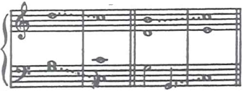

Starting from 6 voices and above, similar motion to 5th or 8ve on main degrees (I, IV, V) is allowed between external voices, if higher voice is moving stepwise.

### Similar motion to 5th or 8ve between internal voices

Similar motion to 5th or 8ve between is allowed except when both voices are external[14]:

1. If one of voices is moving stepwise[15]:

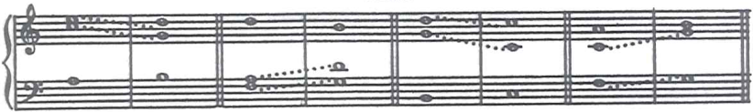

1. Even when both voices have leaps, if one of notes forming interval is part of a previous harmony (common note):

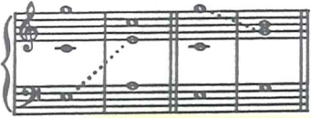

Similar motion to unison is prohibited. Similar motion to tritone without bass is allowed.

**Exceptions:**

Starting from 6 voices and above, similar leaping motion to 8ve is allowed even without a common note, except when both voices are external.

### Sequential 2nds, 7ths, 9ths

1. Sequential 2nds should be avoided[16]:

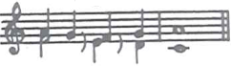

1. Sequential 7ths or 9ths are allowed, especially if second interval is minor 7th or major 9th:

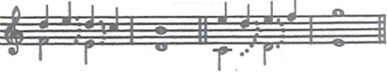

Major 7th and minor 9th sound harsh without another voice. They are allowed if they are accompanied by the third voice, which forms harmonic consonance interval with one of notes of major 7th or minor 9th.

### Similar motion to 2nd, 7th and 9th

1. Similar motion to major or minor second should be avoided[17].

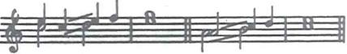

1. Similar motion to 7th or 9th is acceptable between non-extreme voices, especially if it is minor 7th or major 9th:

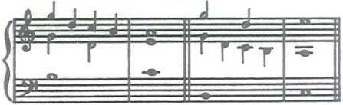

Similar motion to 7th or 9th is prohibited between extreme voices.

Major 7th and minor 9th can be alleviated with a common note when there are at least three voices:

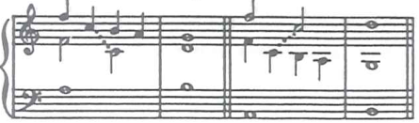

### 2nd, 7th or 9th at the beginning of the voice

It is allowed to start the voice with vertical major 2nd, minor 7th or major 9th.

It is prohibited to start voice with vertical minor 2nd, major 7th or minor 9th, especially if the other voice does not form consonance interval with one of notes, which form a dissonance interval:

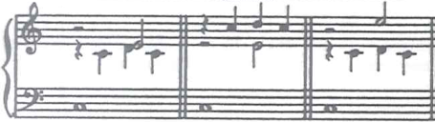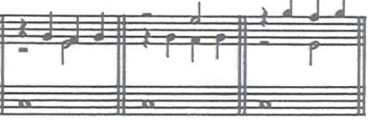

### Distance between voices

This distance is the result of melodic development of voices and can be very variable. Yet, on downbeat in each measure distance between neighboring voices should not exceed two octaves.

This distance can be two octaves or even more inside measure.

### Voice crossing

Voice crossings are often justified by melodic development of the voices. Yet, voice crossings should be generally avoided and limited for good polyphonic balance.

**Exceptions**:

Starting from 3 voices and above, short voice crossings are allowed between neighboring voices, except the first and the last measure.

Starting from 5 voices and above, voice crossings are allowed even in the last measure. Voice crossings in the first measure are always prohibited.

### Voice crossing arrangement

Voice crossing can happen during contrary or oblique motion of the voices, but should not happen during similar motion of the voices[18].

1. Contrary motion of the voices

|  |  |
| --- | --- |
| * 1. Through unison – good: |  |
| * 1. Through second – possible: |  |

Yet, two sequential seconds should be avoided, because this degrades sound quality:



1. During oblique motion unison is possible if §53 rules are not violated.

### Doubling

1. All notes, harmonic and melodic, except suspension, can be doubled. Leading tone can also be doubled as other notes[19].
2. Note doubling should be accomplished across octave or two octaves. Unison doubling is allowed only when §53 rules are not violated.

### Unison

1. Unison can be used on upbeat. Unison is allowed on downbeat only in the first and the last measure.

**Exception**:

Starting from 5 voices and above, unison is acceptable on downbeat in any measure[20].

Unison should be used on downbeat as seldom as possible, because it makes polyphony sound less rich.

1. Movement to unison should be contrary (stepwise or leap) or oblique (only leap).

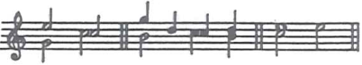

In difficult cases oblique you can use motion to unison from major 2nd (but not from minor 2nd):



Similar motion to unison is prohibited:

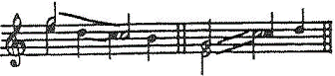

1. Unison can be left by any movement (similar, oblique, contrary), stepwise (to major or minor 2nd) or by a leap.

### 4th. Diminished 5th.

1. Perfect 4th, augmented 4th and diminished 5th are not allowed between chord tones in external voices.

Yet, these intervals often appear between melodic notes of external voices.

**Exception**:

Starting from 4 voices and above, diminished 5th is allowed between external voices, only in penultimate measure, when suspension resolves to leading tone in bass.

1. Perfect 4th, augmented 4th and diminished 5th are allowed between chord tones without bass.

### Harmonic tritone

1. Harmonic tritone[21] is prohibited between bass and any other voice, if both notes of tritone are chord tones. Harmonic tritone is allowed if one of notes is not a chord tone.

**Exceptions**:

Starting from four voices and above, harmonic tritone is allowed with bass only in penultimate harmony, when suspension resolves to leading tone in bass:

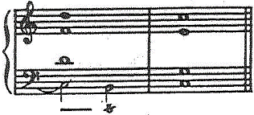

1. Harmonic tritone is allowed between any two voices except bass, but each of its notes requires correct resolution:

In major:

|  |  |
| --- | --- |
| **Note** | **Should resolve to** |
| IV | III |
| VII | I |

In minor:

|  |  |
| --- | --- |
| **Note** | **Should resolve to** |
| II | III |
| III | II |
| IV | III |
| VI | V |
| VI# | VII |
| VII# | I |

**Exceptions**:

Each tritone note, which does not continue until the end of current harmony, will not require resolution.

### Second inversion chords

Second inversion chords are prohibited[22]:

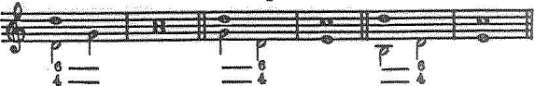

**Exceptions**:

Temporary second inversion chord is allowed on upbeat in case of immediate return to tonic in bass:



### Obligatory harmonies

1. The first and the last measures have to be harmonized with tonic chord in root position.

In two voices counterpoint has to start with degree I or V, and end with degree I.

In three voices, if voice starts with half note or quarter note, this note has to be degree I or V. If first note is a syncopation, it can be a degree III. Notes arrangement in the last measure can be arbitrary (unisons or octaves).

1. Penultimate measure can be harmonized by:
   1. Chord V (in root position or first inversion).

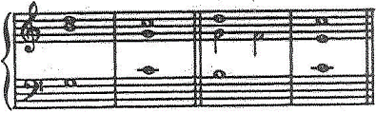

* 1. Chord VII (in first inversion)



Starting from 4 voices and above, chord VII is allowed in root position if suspension resolves to leading tone in bass (see §55).

* 1. Chord II (in root position), if leading tone exists in this measure as a passing tone to tonic note:

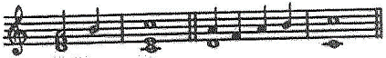

### Incomplete chords

1. Starting from 3 voices and above, all three chord tones should appear on downbeat for rich sound, if possible.
2. In any number of voices, chords in the first and the last measure can be incomplete (3rd or 5th chord tone can be missing) in all counterpoint species (including mixed species).

In other measures (not the first and not the last) incomplete chords are allowed in three voices under the following conditions:

1. There should not be two incomplete chords (the first and the last chords do not count).
2. Two incomplete chords should not follow each other immediately.
3. Penultimate chord should always be complete.

Missing 3rd tone in a chord is allowed only in the first and the last measure.

### Harmonic rhythm

There should not be more than one harmony in a single measure. Yet, the same harmony can continue during several measures.

**Exception**:

Penultimate measure can include two following harmonies:

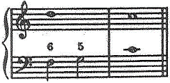

In counterpoint species 4, two harmonies in a measure are allowed in difficult cases to avoid syncopation interruption. It is especially acceptable if syncopations are in bass.

### Modulation

Counterpoint usually does not modulate. Yet, short temporary modulation is possible into closely related key – but not more than once per exercise.

Note, which characterizes new key, should be harmonic and not only melodic. Return to main key should also happen with a harmonic note. Exercises in minor key should not modulate to parallel major through chord III.

Chromatic interval is always prohibited.

# Non-chord tones

## Suspensions

### Suspensions, which resolve down

Suspension of any degree can resolve down.

Only sharp VI degree during ascending movement in melodic minor cannot resolve down.

### Suspensions, which resolve up

Suspension resolution up can be used in the following cases:

1. Leading tone resolution into tonic of a minor key:



1. Consonance suspension:



In the latter case, a perfect 5th can be considered a chord tone – in this case there would be two harmonies in a measure.

### Suspension preparation

1. Suspension preparation should not be shorter than a half note:



Starting from 5 voices and above, suspension can be prepared with a whole note.

1. If suspension resolves to 5th interval, this suspension should not be prepared by 5th interval (same for 8th):

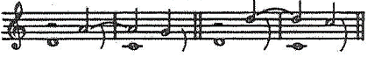

**Exception**:

This is acceptable if second voice moves during the suspension resolution:

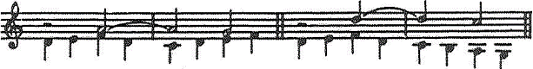

### Suspension resolution

Suspension should resolve on third quarter of a measure:



Yet, there can be another chord tone between suspension and suspension resolution[23]:

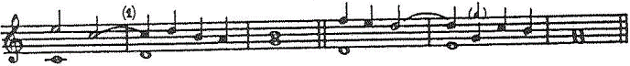

**Exception**:

An earlier suspension resolution is possible if resolution note still appears on third quarter of the measure:



If suspension resolution doubles, avoid similar motion to 8ve:

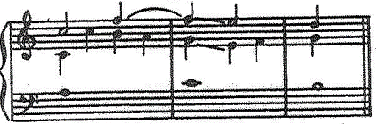

### Suspension and resolution

Suspension resolution should not sound simultaneously with suspension, except for the case, when suspension resolution is in bass and the interval between suspension and suspension resolution has to be greater or equal to 9th:

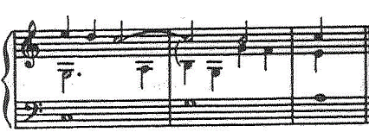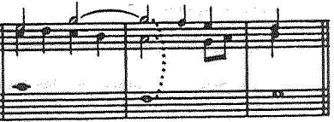

The interval between suspension and suspension resolution can be a major 2nd:

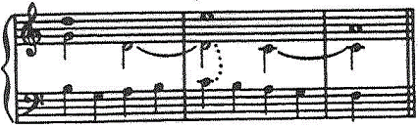

**Exceptions**:

Starting from 4 voices and above, suspension can sound simultaneously with suspension resolution if resolution is in internal voice and voices have stepwise contrary motion:

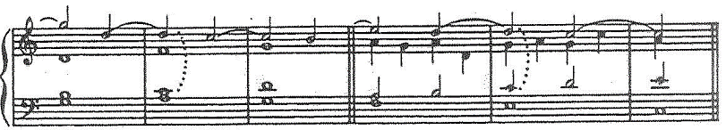

Suspension should not sound simultaneously with suspension resolution, if suspension is below when they sound together:

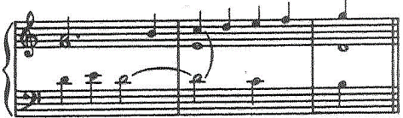

## Passing and auxiliary tones

### Passing and auxiliary tones

|  |  |
| --- | --- |
| Descending and ascending passing tones | Upper and lower auxiliary tones |
|  |  |

Usually passing and auxiliary tones appear on upbeat. As an exception, passing tone is acceptable on downbeat simultaneously with suspension, especially with contrary stepwise motion:

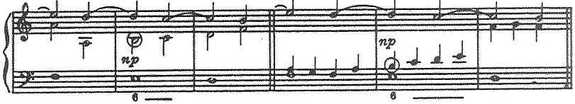

When harmony does not change during two measures, passing or auxiliary tone can occur on downbeat of the second measure.

### Simultaneous sounding of melodic and harmonic notes

Passing and auxiliary tones can sound simultaneously with chord and non-chord tones in case of contrary motion.

In case of similar motion these intervals obey the rules § 44, § 45.

See § 53 concerning oblique motion to unison.

### Double neighbor tones

Double neighbor tones and their resolution tone can sound simultaneously (resolution to octave).

Double neighbor tones cannot resolve to unison.

See § 34 concerning the use of passing and auxiliary tones in melodic minor.

1. Exception: short-term modulations into adjacent mode (see §60).
2. Exceptions:

   Tritones and 4th intervals on first beat of harmony are allowed between chord tones if these intervals are formed without bass.

   Passing downbeat dissonance (PDD) is allowed in species 1, 3, 5. In species 2, 4 PDD is allowed if absolutely needed.
3. Exception: Tritones and 4th intervals can be formed by suspension resolution note if these intervals are formed without bass.
4. Fifth species rhythm also can be introduced in one of voices.
5. In difficult cases these rhythms are allowed in 4 voices in soprano. Starting from 5 voices and above, whole note can be slurred with a shorter note.
6. At the same time four half notes or 8 quarter notes are allowed in three consecutive measures:

   
7. Leaps of a 4th or 5th are allowed between measures as a last resource, even if they are prepared by movement in the same direction:

   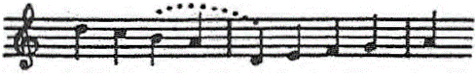
8. Starting from three voices, a half note or quarter note can be repeated between penultimate and last measure (anticipation):

   
9. Number of voice pair that have to be controlled when number of voices in counterpoint grows:

   |  |  |
   | --- | --- |
   | Number of voices | Number of voice pairs |
   | 2 | 1 |
   | 3 | 3 |
   | 4 | 6 |
   | 5 | 10 |
   | 6 | 15 |
   | 7 | 21 |
   | 8 | 28 |

  
10. Compound intervals follow the same rules as simple intervals (e.g. 10th and 3rd). Only unison and octave, 2nd and 9th have different rules.
11. You can write three or more sequential 6th chords, if at least two voices have contrary motion:

    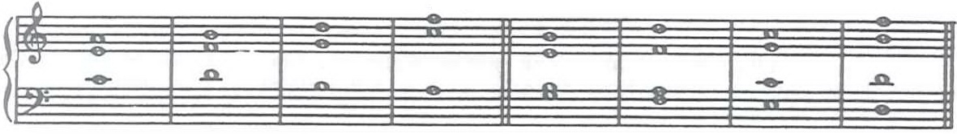
12. Similarly, 5ths between syncopated harmonic notes on downbeat are allowed (but not 8ves):

    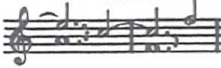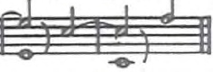

    Similarly, close 5ths or 8ves are allowed, if second interval is formed by harmonic note, surrounded by stepwise motion, resembling a passing or auxiliary tone:

    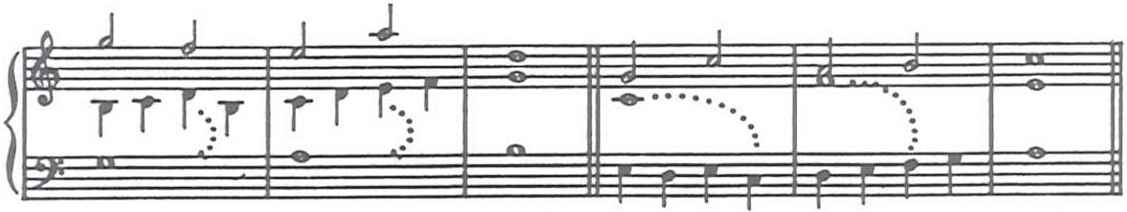
13. In difficult cases this exception can also be used in 4 voices.
14. This means between two internal voices or between one internal voice and one external voice.
15. If only lower voice is moving stepwise, then similar motion to 5th on secondary degrees (II, III, VI) should be avoided in 5 voices. Also, similar motion to 8ve down should be avoided:

    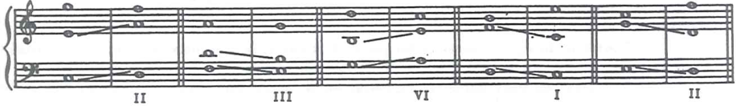
16. Exception: two sequential 2nds are allowed if second interval is a major 2nd (and never if it is minor 2nd).
17. Similar motion to major second is acceptable, if one of notes of this interval sounded immediately before this second:

    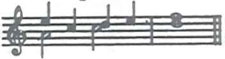
18. Voice crossing is acceptable during similar motion of the voices, if at least one voice moves stepwise:

    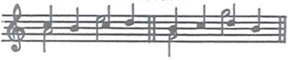
19. Yet, leading tone doubling in bass should be avoided, because it decreases sound quality.
20. In 4 voices unison can be used between two lowest voices on downbeat if this is needed for melodic development.
21. If both notes of tritone do not sound simultaneously, this is not considered a harmonic tritone. On the other hand, if both notes sound simultaneously, but do not start simultaneously, this is still considered a harmonic tritone.
22. The following examples are allowed if rule §59 is not violated (two harmonies in one measure to avoid syncopation interruption in bass):

    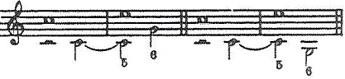
23. 8ves in the first example are acceptable, because quarter note D can be considered auxiliary.